Date: 15.10.2021
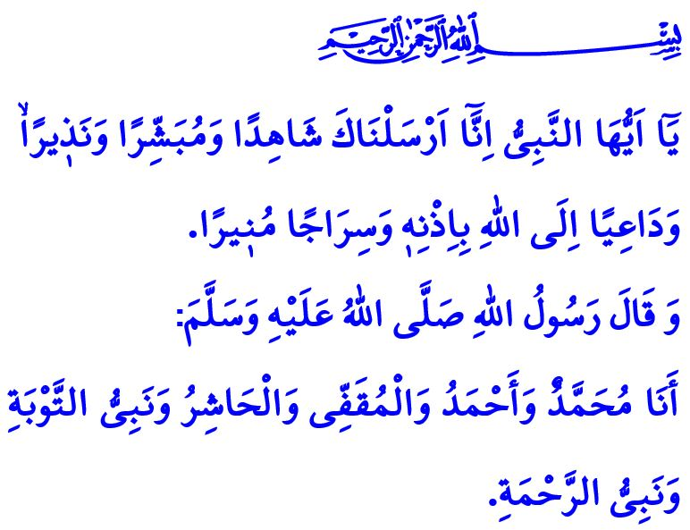
A BLESSED NIGHT: MAWLID AL-NABI
Honorable Muslims!
Next Sunday night is Mawlid al-Nabi. It marks the anniversary of our Prophet Muhammad Mustafa (saw)’s honoring the world with his birth, who is Islam’s notifier, the representative of justice and truth, the master of this world and the Afterlife, our best guide and model. Endless thanks and praise be to our Almighty Lord (swt) for allowing us to arrive at this wonderful night, and salat and salam be to our Prophet (saw), whose ummah we are honored to be a part of, as well as to his family and companions.
Dear Believers!
In the verse I have recited at the beginning of my khutbah, Allah the Almighty (swt) says, “O Prophet! Indeed We have sent you as a witness and a bringer of good tidings and a warner, and one who invites to Allah, by His permission, and an illuminating lamp.”
In the hadith I have read, our beloved Prophet (saw) introduces himself as follows, “I am Muhammad, and Ahmad (praised one), and Muqaffi (the Last Prophet); and I am also Hashir (the final Prophet in the presence of whom the dead will be resurrected); and the Prophet of repentance, and the Prophet of mercy.”
Dear Muslims!
It is the Messenger of Allah (saw), the guidance of our life from whom we learn the Qur’an and Sunnah. It is through him (saw) that we learn loyalty, kindness, friendship, and affection. He (saw) is the one who brought mercy-laden justice and wisdom-laden morality to all of humanity. He (saw) is the one who showed us the deeds that lead to paradise. He (saw) is the one via whom our hearts are connected. He (saw) is the one thanks to whom our world gains meaning and our life gets blessed.
Dear Believers!
In today’s world, where values are degenerated and disloyalty is rampant, our only way out is to communicate our Prophet’s (saw) advices to all of humanity. So, let us make an effort to understand our Prophet (saw) better. Let us tightly embrace the greatest legacy of the Messenger of Allah (saw), the Qur’an, and the Sunnah, which illuminates our path. Let us purify our nafs with his good morals. Only then will our day be the ‘Asr al-Sa’adah (Age of Bliss) again. Only then, inshallah, will our world be full of peace, and our Afterlife paradise.
Dear Muslims!
As we do every year, we will observe the week in which the Night of Mawlid falls as the Mawlid al-Nabi Week this year as well. The Presidency of Religious Affairs has decided this year’s theme for Mawlid al-Nabi Week to be “The Prophet Muhammad and the Society of Loyalty.” Loyalty implies value and worth for individuals, as well as peace and happiness for society.
The finest examples of loyalty, as in other areas, are represented by the Prophet Muhammad for humanity. We will share with our society the examples of our Prophet’s (saw) loyalty to his parents, spouse and children, relatives and friends, and all existence whether alive or non-living, via the events and activities that will be held throughout the Mawlid al-Nabi Week. We will make an effort to recall our bond with our Almighty Lord (swt) and renew our promise of loyalty to all humanity and the universe.
I would like to take this opportunity to congratulate you on Mawlid Night and to pray to Allah the Almighty (swt) that our week would be prosperous for our great nation, the Muslim world, and all humanity.

Ahzab, 33/45, 46.
Muslim, Fadha’il, 126. General Directorate of Religious Services

